**Mountain View Public Library**

**1000 Maple Avenue, Claremont, TN 38325**

**(615) 555-0982**

Volunteer Newsletter, Winter Edition

# New Classes at the Library

We have several new computer classes for children and adults during February and March and are in need of volunteers to assist. If you are interested, please contact Abigail Gardner.

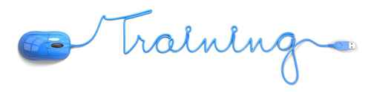

Coding for Kids: Children ages 8-12 learn basic computer programming for software application development.

When: Every Tuesday in February at 3 p.m.

Where: New Media Center

Senior Travel: Seniors learn how to effectively search for travel opportunities, make reservations, and read and post reviews.

When: Every Thursday in March at 6:30 p.m.

Where: East Branch

Photo Editing: Learn how to organize and edit photos using popular photo editing software.

When: Every Thursday in February at 7 p.m.

Where: Main Library

Personal Finance with MS Excel: Learn how to use this powerful spreadsheet program to organize your personal finances.

When: Every Tuesday in March at 7 p.m.

Where: New Media Center

# New Volunteer Orientations

Do you know someone who is interested in volunteering at the library? We have several upcoming volunteer orientations scheduled in February and March. Volunteers are needed for all shifts and perform a variety of duties, including: circulation, book processing, youth activities, and computer lab assistants. Please ask potential volunteers to contact Abigail Gardner for additional information.

# Volunteer Spotlight

Joan Daniels, an energetic volunteer at East Branch Library, is celebrating her fifth anniversary as a library volunteer. Joan started volunteering at the East Branch two weeks after it’s opening and has been with us ever since! As a former elementary school teacher, Joan enjoys working with children in the after school reading and tutoring program.

# February Birthdays

|  |  |
| --- | --- |
| Date | Name |
| 17 | Lydia Barton |
| 18 | Anthony Sanchez |
| 20 | Trent Zimmer |
| 27 | Susan Matthews |

If you have a garden and a library, you have everything you need. Cicero